Power Economics Homework 2
Nicolas Dominguez
EEL4298-26 Fall 01

Note: In these problems, π represents price, not the mathematical constant pi (approximately 3.14159).

2.5: The demand curve is q = 200 − π. Calculate the price and price elasticity of demand for q = 0, 50, 100, 150, and 200. Repeat for q = 10000/π.

Use signed price elasticity ε = (dq/dπ)(π/q).
q = 200 – π
π = 200 – q
dq/dπ = -1
Now plug π and dq/dπ into signed price elasticity equation
ε = - (200 – q) / q
Demand q | Price π | Signed elasticity ε
0 | 200 | Undefined
50 | 150 | −3
100 | 100 | −1
150 | 50 | −1/3
200 | 0 | 0

Now we use the new demand curve expression
Use signed price elasticity ε = (dq/dπ)(π/q).
q = 10000 / π
π = 10000 / q
dq/dπ = -10000 / π²
Now plug π and dq/dπ into signed price elasticity equation
ε = -1
Demand q | Price π | Signed elasticity ε
0 | No finite price | Undefined
50 | 200 | −1
100 | 100 | −1
150 | 66.6667 | −1
200 | 50 | −1

2.8: A firm’s short-run cost function for the production of gizmos is given by the following expression:
C(y) = 10y² + 200y + 100 000
a. Calculate the range of output over which it would be profitable for this firm to produce gizmos if it can sell each gizmo for $2400. Calculate the value of the output that maximizes this profit.
Revenue is R(y) = 2400y
Profit is P(y) = R(y) – C(y)
So, P(y) = 2400y – 10y² – 200y – 100000
P(y) = –10y² + 2200y – 100000
Using a plotting tool, I found that the zeros are 155.8258 and 64.1742
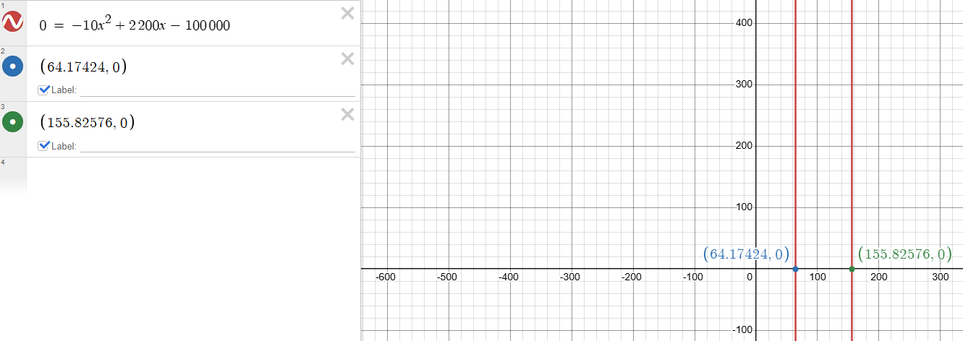
The output range for the gizmos if they sell each gizmo for $2400 has to be between 65 and 155 and the maximum amount created that will yield the most output is 110, which is hallway between the range.
P(y) = –10(110)² + 2200(110) – 100000 = $21000
If we plug in 110 into our profit expression, we get the maximum profit at $21000.
b. Repeat these calculations and explain your results for the case in which the short-run cost function is given by
C(y) = 10y² + 200y + 200 000
Revenue is R(y) = 2400y
Profit is P(y) = R(y) – C(y)
So, P(y) = 2400y – 10y² – 200y – 200000
P(y) = –10y² + 2200y – 200000
Using the plotting tools, I found that using this expression allows for no profit in any situation. In the best-case scenario, which is again 110 gizmos, we are at a -79000 deficit.
